Visual Builder Instance with ORM stack

Contents

1. Introduction 3
2. Workflow diagram to deploy the stack 3
3. Create stack for Visual Builder Instance 4
4. Plan the Job 6
5. Apply the Job 8
6. Verify in the Console 9
7. Destroy the stack 10

Introduction
In the context of Oracle Cloud Infrastructure (OCI), there is no specific service called "Visual Builder." However, OCI provides a range of services that can be used for building applications, including visual development tools and services.
Although not specific to OCI, Oracle Visual Builder is a cloud-based, low-code development platform that can be used to build web and mobile applications. It provides visual development tools, drag-and-drop components, and declarative programming capabilities.

Prerequisites:
- Visual builder Create only in the Root Compartment

Workflow diagram to deploy the stack

Below diagram shows how the Terraform Artifact are applied in the OCI. While creating a ORM stack, using terraform deliverables Init, Plan and Apply is the flow to provision the resource in the OCI. We can have the deliverables in any of below.

- GitLab/GitHub Repo
- Bitbucket
- Can be in folder/.zip in the local disk
- Object Storage Bucket
- Can be in compartment
- Oracle provided Template


Create stack for Visual Builder Instance
Go to OCI Console Developer Services Resource Manager Stacks select the compartment Create Stack

My Configuration Folder Browse Select the “Visual Builder” folder that contains the terraform Upload

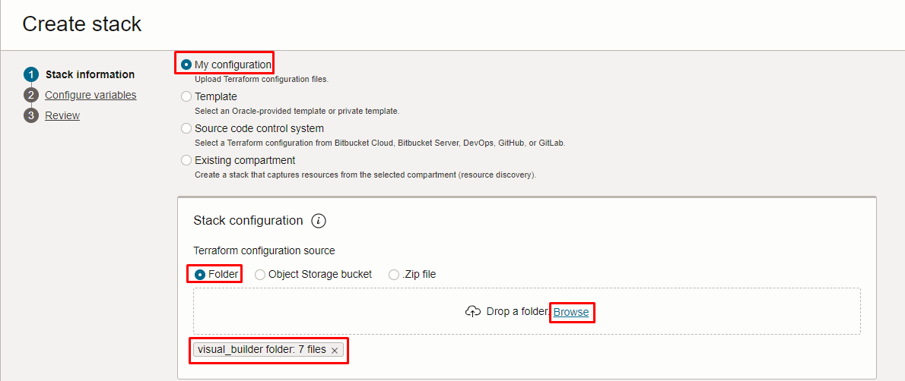
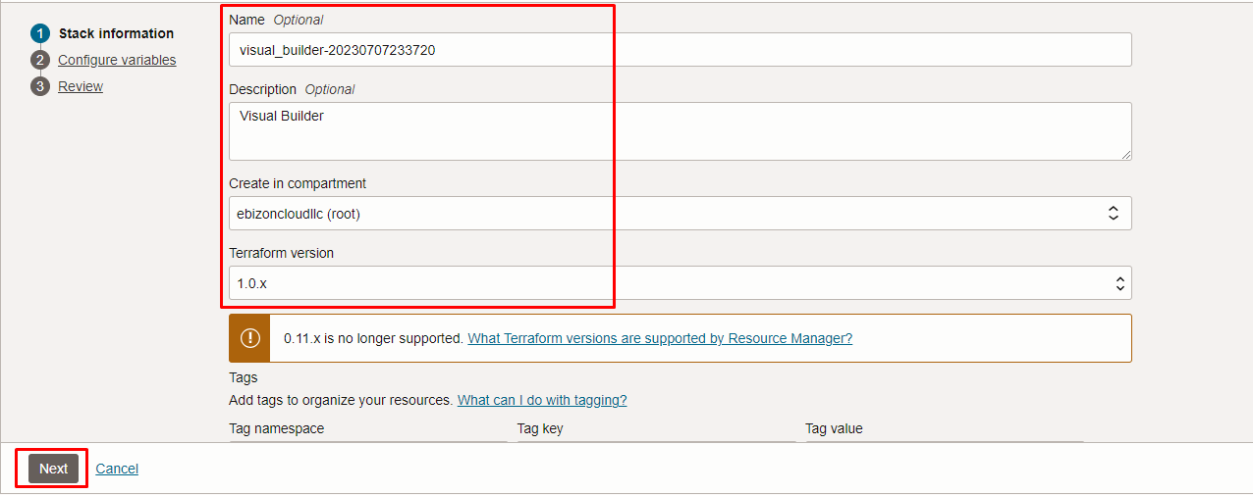

Click “NEXT”
Select the parameters as per the below screen,

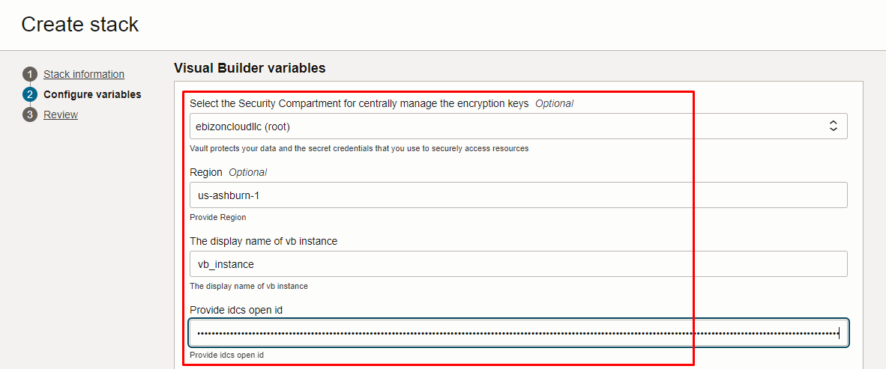
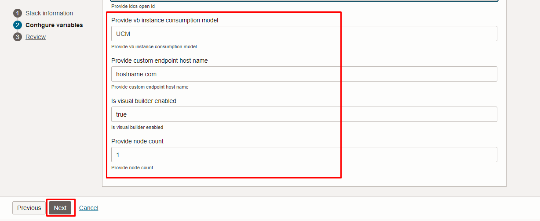

Click “NEXT” Click “CREATE”

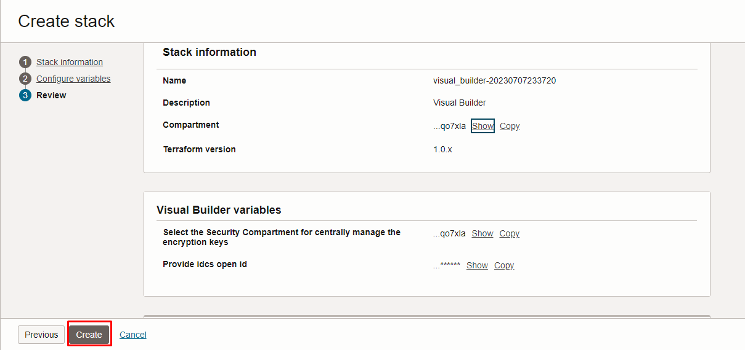

Plan the Job

Click the “Plan”
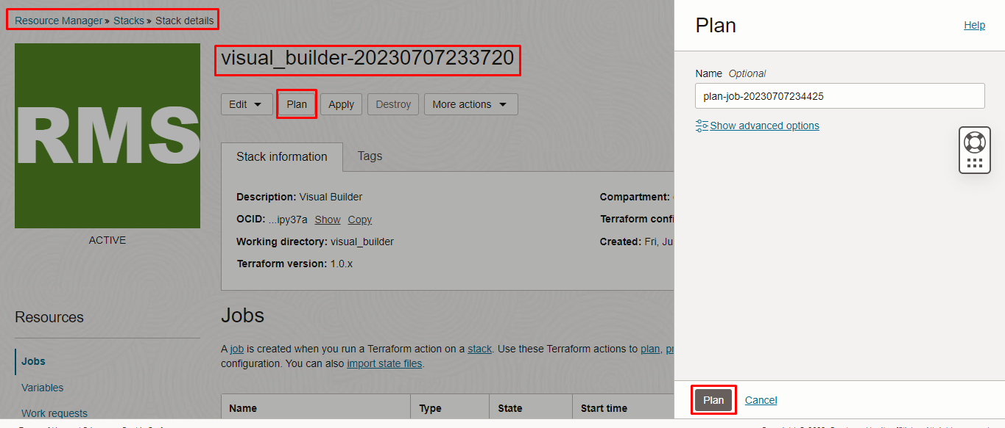
Verify the Plan is successful.
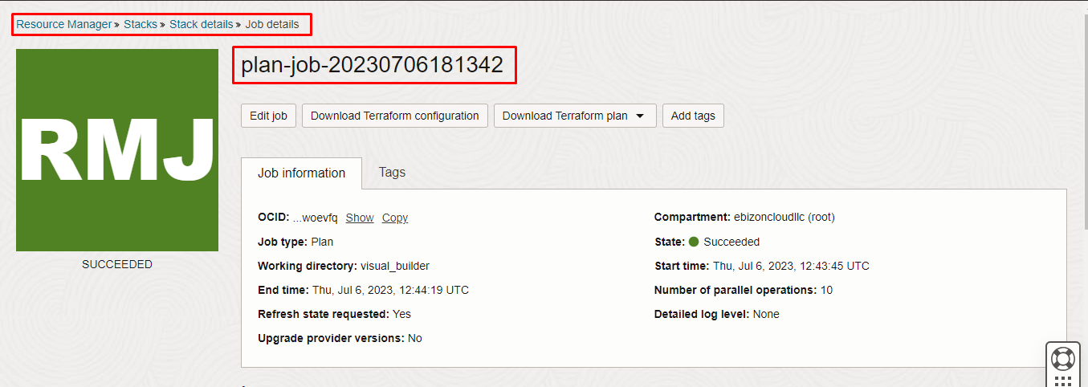
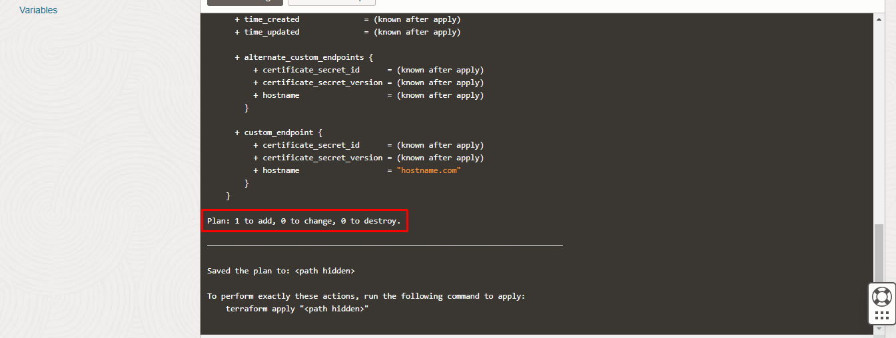

- Apply the Job
Once the “plan” is success, now click “Apply”

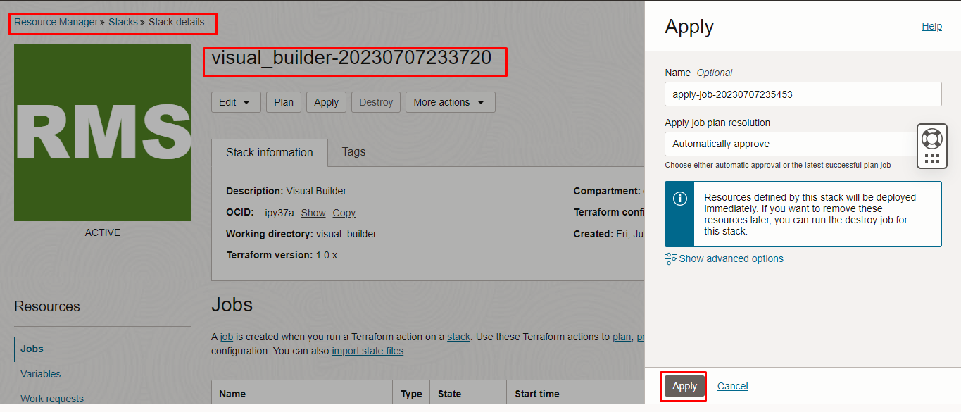

Verify the Apply is successful.

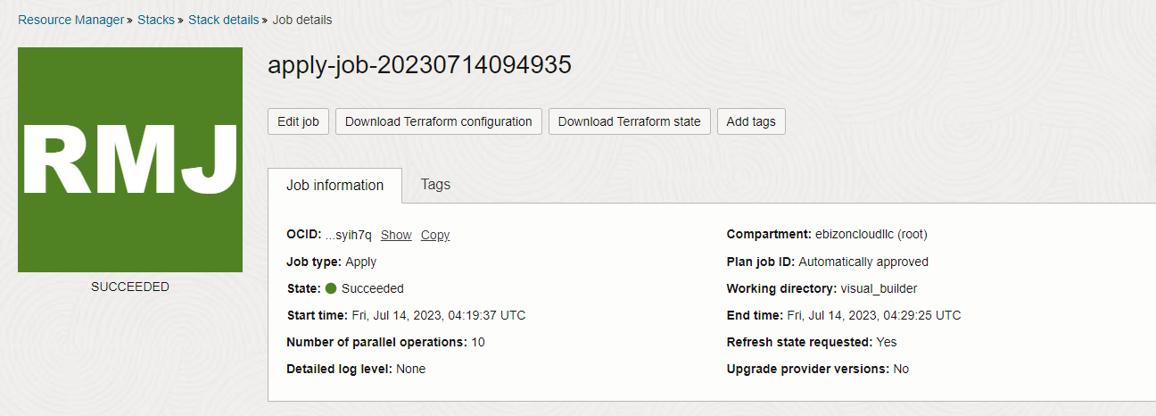
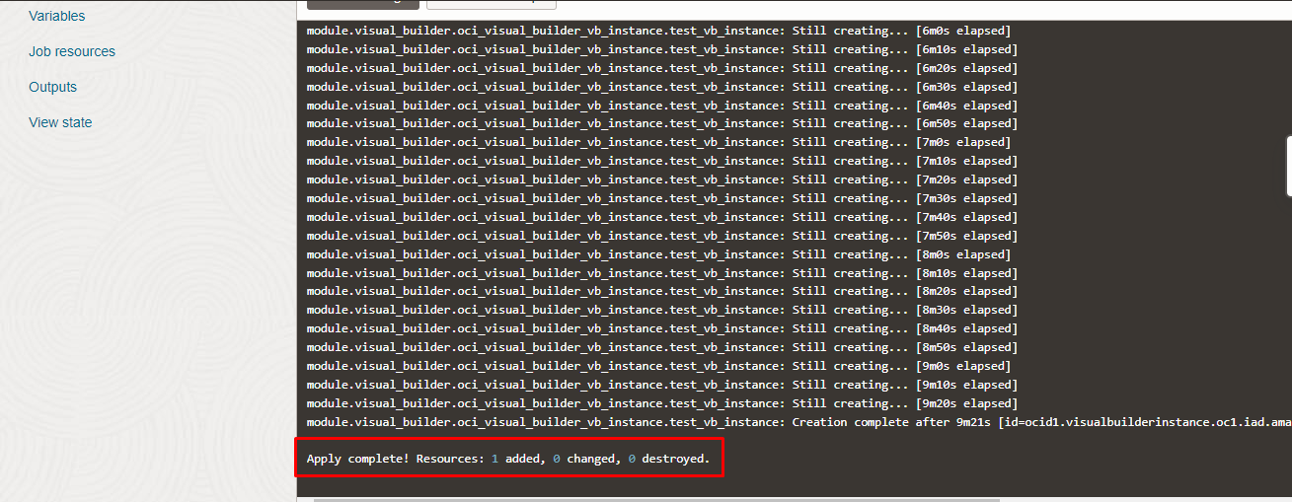

Verify in the Console

Go to OCI Console Developer Services Visual Builder

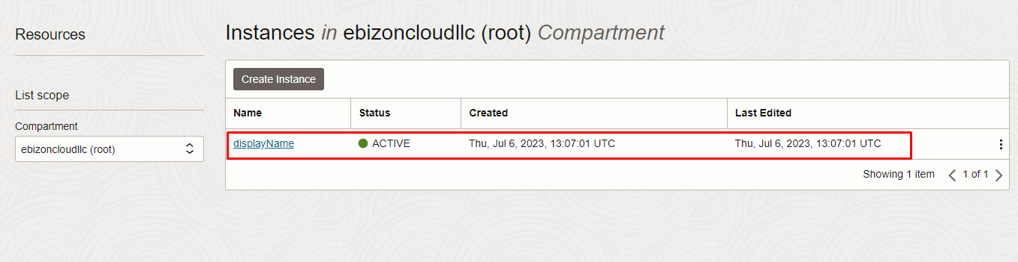
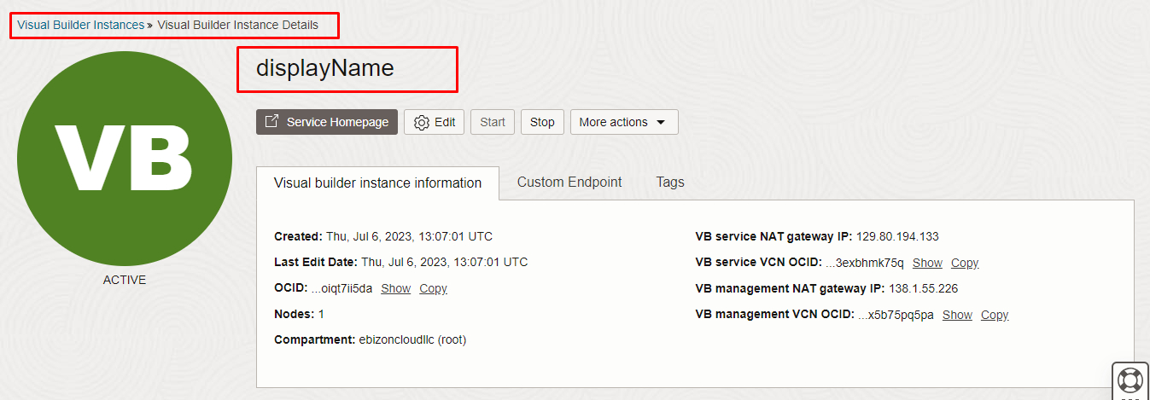

Destroy the stack
Create a destroy job in Resource Manager to release resources associated with a stack and clean up the tenancy. Once destroyed data cannot be recovered from resources.

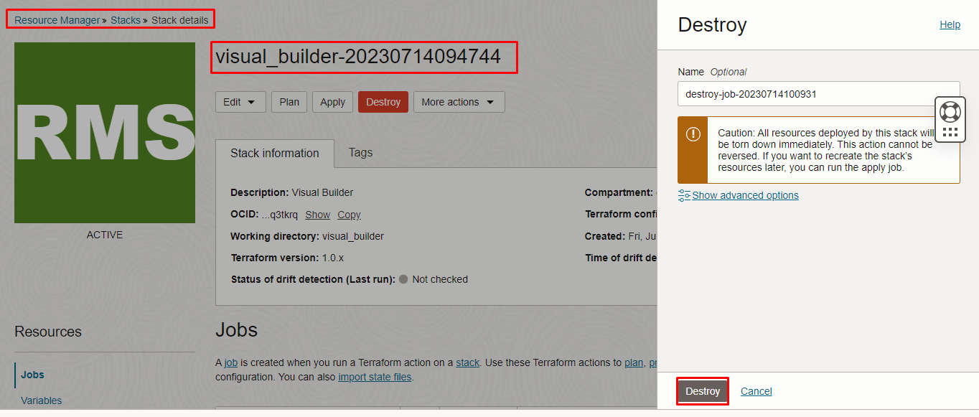

###END###

